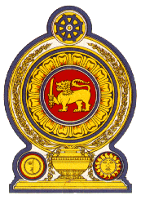

**44th Session of the Universal Periodic Review**

**Review of Bangladesh - 13th November 2023**

**Statement by the Democratic Socialist Republic of Sri Lanka**

Mr. President,

Sri Lanka warmly welcomes the delegation of Bangladesh and appreciates the comprehensive presentation made.

Sri Lanka commends measures taken by Bangladesh since its third UPR review cycle in 2018 towards adopting legislative and policy reforms and enhancing democratic institutions.

We also note the significant efforts to ensure and uphold the rights of migrant workers as well as the 8th Five-year plan (2020-2025) to improve overseas employment and the well-being of migrant workers.

In a constructive spirit, Sri Lanka recommends that Bangladesh;

1. Continues to pay attention to the issue of trafficking in persons both at the national and international levels with a view to eliminating trafficking in persons;
2. Continues to work with host countries for mutual recognition of skills, qualifications and competencies of migrant workers.
3. Continues efforts towards addressing the negative impacts of climate change and building resilience against adverse effects of climate change, particularly incidents of salinity and flash flood.
4. Continues to update strategies and strengthen efforts to combat terrorism and violent extremism notably through a ´whole of society´ approach.

We wish Bangladesh success in its UPR engagement.

Thank you